sd | English Year 1/2 Overview 2024 – 2025
 | Week 1 | Week 2 |  | Week 3 | Week 4 |  |  | Week 5 |  | Week 6 |  | Week 7 |  | Week 8 | Week 9 |  | Week 10 |  | Week 11 |  | Week 12 |  | Week 13 |  | Week 14 |  | Week 15
Autumn Core Texts | English Link - History - Changes within living memory - toys |  |  |  |  |  |  |  |  |  |  |  |  | Our local area
 | The bear who nothing to wear – Willis & Fitzgerald 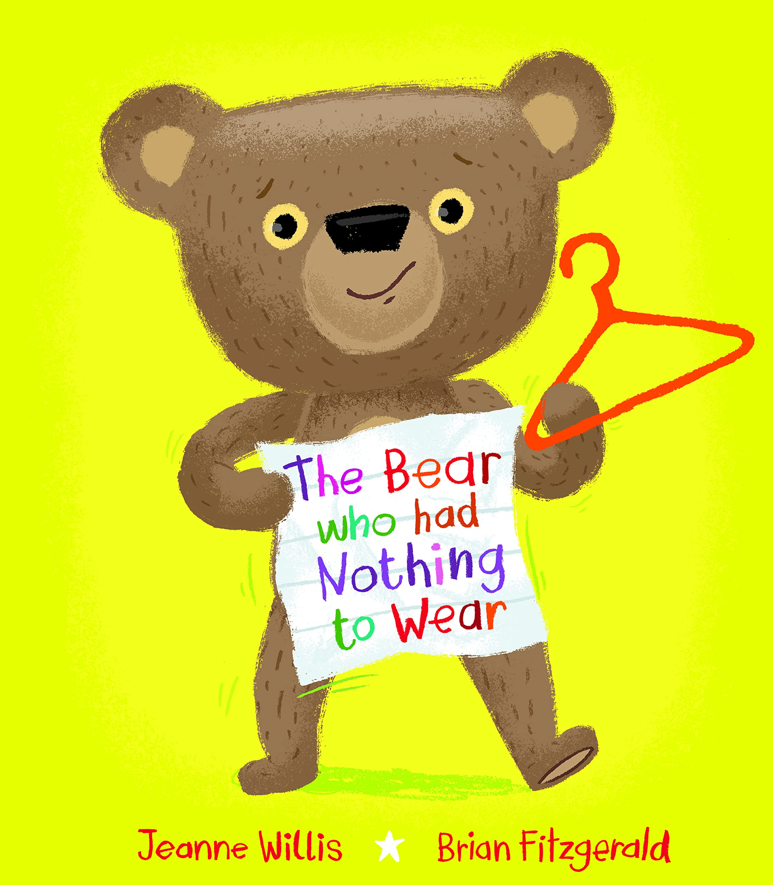 |  | Boris starts school –  Weston & Warnes  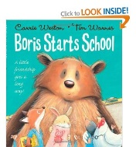 |  |  | Already have a class teddy that goes missing. Day 2 other bears go missing & there are foot prints.  The teddy robber – Beck |  |  |  |  | Have a teddy bears picnic to celebrate finding the bear  Watch clip & voiceover  Fact page about teddy bears |  | (Bears coming to life eg. Winnie the Pooh)  What’s in the box? Millum  The toy’s playtime – Mitton | Link to geog. topic  Watch a walk around the local area / Google maps  Maya’s Walk – Butterfield & Geyer/ Chasing rainbows – Grant  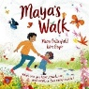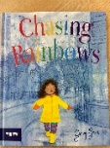 |  |  |  | Bog Baby – Willis  Don’t show front cover until later  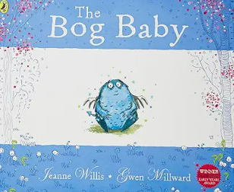 |  |  |  |  |  |  |  | Whiffy Wilson the wolf that wouldn’t wash – Hart & Lord  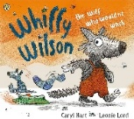  Image of a clean wolf! 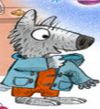
Writing Outcomes | Discuss how bear felt in his different outfits – use images of him/emoji for emotions –  Design an outfit that you think bear would love – write a simple sentence |  | Opportunities to write in simple sentences  Draw the class teddy and write a simple sentence about it.  Write a sentence about why the animals are scared.  He is big.  He has claws.  He had huge claws and sharp teeth (Yr 2)  How did Boris feel?  Speech bubble from a rat. |  |  | A missing poster for our class bear. | A story map of the journey from Tom’s house to the Giant’s door – orally retell/  write a simple narrative. |  | Giant sends a thank you letter to Tom for helping him find his teddy. |  | An information page / booklet about the history of bears. |  | A list poem about the toys coming to life  Eg The doll danced.  Developed in Yr 2  The monkey jumped out. (using prepositions  / adjectives)  The cheeky monkey jumped out. | A recount of a walk around the local area . |  | A list poem about all the different things that she sees in the story |  | Verbally explore travelling through the woods looking for the pond.  Have you seen a Bog Baby poster?  (character description) |  | Instructions for looking after Bog Baby:  Eg. Cuddle the Bog Baby  Cuddle the Bog Baby so he feels happy. |  | Discuss why they think Bog Baby is ill and what they should do.  3 sentences about him being poorly.  Speech bubble as the Bog Baby telling them how he feels and asking for help. |  | Make own Bog baby.  Yr 1 retell the story simply.  Yr 2 Create a story about the day the Bog Baby came to the school  Story map the idea and write a simple story. (see modelled text in file) |  | A speech bubble from Dotty tellling him why it is important that he is clean . | Tell the story about his cousin Wolfy who is always clean. Whiffy & Dotty want to show him how to enjoy being muddy! Work together to create a story that pupils can recreate.
 |  |  |  |  |  |  |  |  |  |  |  |  |  |  |  |  |  |  |  |  |  |  |  |  |  | A letter of apology from Whiffy to his Mum explaining that he will not be naughty again
GPS | Speak in sentences  Hold a sentence  See simple sentences modelled |  | Consolidate prior learning - The demarcation of a simple sentence with capital letters and full stops that include a subject (noun) and verb (is). |  |  | Orally rehearse simple prepostions (looking for the giant’s bear) eg. under…  Yr 2 - A series of demarcated sentences. |  |  |  |  | Check that the sentences make sense. Yr 2 include co-ordinating/ subordinating conjunctions |  | Each | Use the personal pronoun I with capital letter. Use ‘and’ to join ideas |  | Yr 1 Use simple adjectives if appropriate  I saw a red leaf.  Yr 2 superlatives  I saw the reddest leaf. |  | Yr 1 Simple sentences describing the Bog Baby  Yr 2 Developing the use of noun phrases to describe. |  | Yr 1 Question sentence at beginning of instruction.  Eg Do you want to find the map?  Yr 2 include co-ordinating conjunctions |  | Yr 1 Use of co-ordinating conjunction and  Yr 2 Use of sub-ordinating conjunction because |  | Yr 2 Use story language to give the text a strong structure  eg. First, then, next |  | Yr 1 Use of question sentences  Yr 2 subordinatin g conjunctions eg If you do not wash you will stink! | Yr 1 Superlatives to describe Wolfy the wolf  Yr 2 Using co-ordinating and subordinating conjunctions
Wrap around | Everywhere Bear – Donaldson & Cobb Old Bear/ Little Bear and the silver star – Hissey  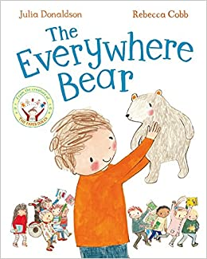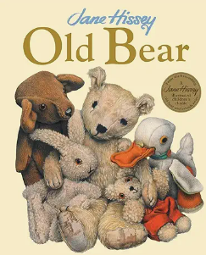 |  |  |  |  |  |  |  |  |  |  |  |  | On the way home – Murphy  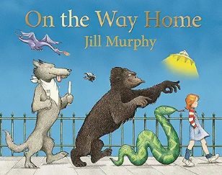 |  |  |  | The King of the tiny things – Willis  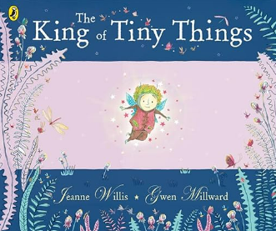 |  |  |  |  |  |  |  | Whiffy Wilson – the wolf who wouldn’t go to bed! –  Hart & Lord 