sd | English Year 3/4 Overview 2024 – 2025
Autumn Core Texts | Week 1 | Week 2 | Week 3 |  | Week 4 |  | Week 5 |  | Week 6 | Week 7 | Week 8 | Week 9 |  | Week 10 | Week 11 |  | Week 12 |  | Week 13 |  | Week 14 |  | Week 15
 | Being brave! |  |  |  |  |  |  |  |  |  | Manchester
 | The lion inside –  Bright & Field  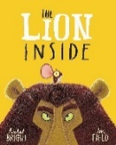  Props – a mouse, mouse ears/lion ears  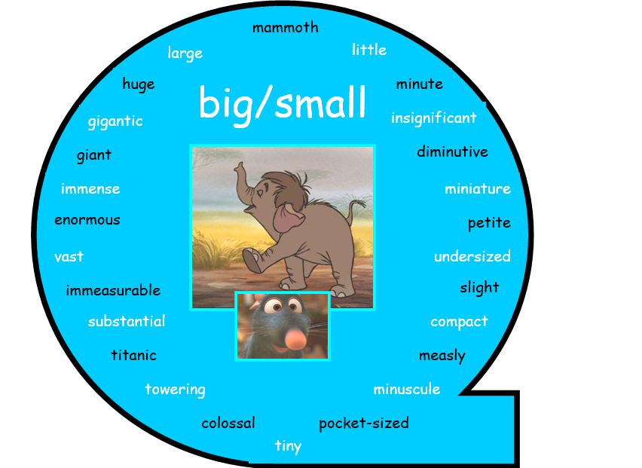 |  |  | Traction Man – Grey  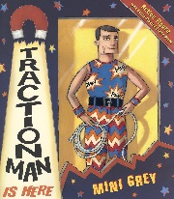 |  |  |  |  | A variety of school poems  Morning break –  Wes Magee  At the end of school assembly – Simon Pitt  Please Mrs Butler – Ahlberg  A kid in my class – Rooney  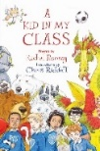 |  | This is the place – Walsh  https://youtu.be/PszMmYpQjPo?si=4nuDIDBRSdfm-CtR  https://www.bbc.co.uk/bitesize/articles/ztj88hv  (PowerPoint – Learn about Bees) |  | Bee and Me – Jay  (a book about a bee in a city like Manchester)  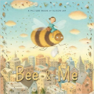 |  |  |  |  |  |  |  |  | Tourist brochures about coming to Manchester Museum  Linked to their visit on  The Time Odyssey  Visit Manchester Museum clip  https://youtu.be/gh32JAuKql8?si=fZm-_aiD16FdWfW9
 |  |  |  |  |  |  |  |  |  |  |  |  | https://youtu.be/v6tUWk7vC6g?si=j8yvtadMqmkG9Kn  Research from Bee texts  You wouldn’t want to live without bees -  Woolf & Antrim / The Bee Book – Milner / The Book of bees – Piotr  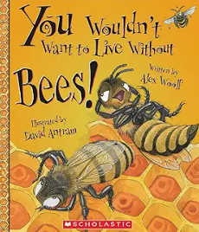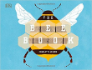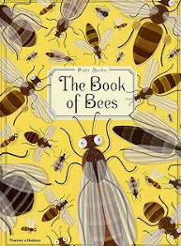  The Not Bad Animals  (Page about wasps)  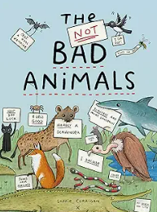 |  |  | This is the place – Walsh  used to inspire a poem from the bees |  | Extract from Bee Movie  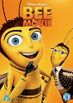  Where the human meets the bee  https://youtu.be/qhuA3FA8olM?si=kSdJ6jlNe0-mKc-b |  | How to make a Bee B and B – Newsround clip  Last page from Bee and Me  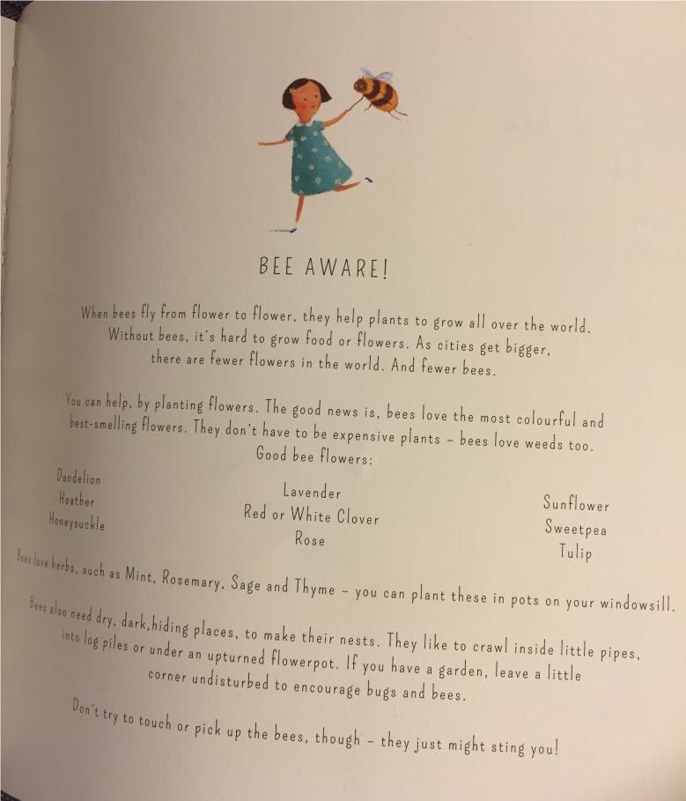
Writing Outcomes | Simple descriptive sentences about the mouse –  Speech bubble as a ignored mouse (conjunctions)  Advice for a mouse (contractions)  Did they like the story? What did you learn from the story?  Teacher models their ideas (because) |  |  | Narrative of the first page of the story |  | Write a new page for the story in the house |  | Write a new page for the book  Traction Man in the classroom | Performance of Please Mrs Butler  List poem  Couplet poem  Instruction poem  Poems based on the Rooney Book with different structures |  | Listen to and Read This is the Place – What does Manchester mean to them?  A short information text about why bees are symbols of Manchester |  | What do we know about bees? Generate lots of questions about bees and retrieve the information. Read up informaiton about bees Discuss the different ways the informaiton texts give information – structure, layout and language – cut up and reconstruct texts .  Non Chronological report about Bees – focus on 4 paragraphs of information that are cohesively taught. |  |  | A poem based on This is the place created by the bees celebrating the great job they do.  Perform the poem as a class |  | Dialogue between a human and a bee about taking the honey. To explore the emotions on both sides.  Action / dialogue/ action (yr 4) |  | Instructions for making a Bee friendly garden. Use last page  (A little bee could be use instead of a bullet point) |  | Watch the clip about Time Odyssey and another about Manchester museum  Tourist guide for visiting Manchester Museum aimed at children
Text Knowledge GPS | Opportunity to consolidate the end of KS 1 standards  To write coherently with accurate demarcation using the different sentence types and punctuation marks. Use appropriate past and present verb tenses.Use co-ordinating and subordinating conjunctions. |  |  | Use adjectives & superlatives to describe the characters |  | Use verbs/adverbs to describe the movement of the characters |  | Use adverbials of time to give more detail to the story | Use a varied and rich vocabulary with growing precision to create the different types of poetry. |  | To begin to think about cohesion across a paragraph so the reader can follow the information. Revisit conjunctions eg. and, but, so because, if Eg Time conjuctions |  | Use appropriate layout features eg headings, subheadings and paragraphing of similar information.  Generate questions to use as subheadings to help to organise information.  Yr 4 to use a topic sentence in each area. Technical language |  |  | To begin to understand that poetry can have a defined structure eg a refrain |  | Use inverted commas to punctuate direct speech. Speech conveys character. |  | To use apporiate layout for instruction  Use of imperative verb for the command. |  | Use appropriate layout for a tourist page eg. headings, subheadings, captions and images  Use adverbial phrases as cohesive devices.
Wrap around | 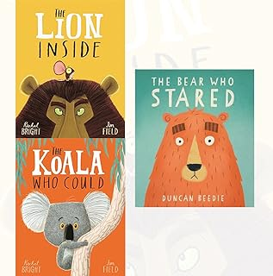 |  |  | Traction Man and turbo dog /  Traction Man and the beach odyssey– Grey 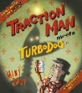 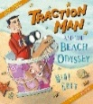 |  |  |  |  |  |  |  |  | Why do we need bees –  Dayes & Pyms  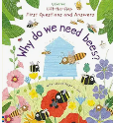 |  |  |  |  |  |  |  |  | Range of brochures advertising different places/activities in Manchester

