Background Notes for Parents/Carers

About the theme – Advent/Christmas
The Advent/Christmas – Loving theme considers Christians’ preparation for the gift of God’s love in Jesus which is celebrated by Christians at Christmas. It focuses on the witness of loving as a way of life.

The season of Advent and the three-fold coming
Advent marks the beginning of the Church’s year. The word ADVENT comes from the Latin word
‘adventus’ which means ‘arrival’, ‘coming’ or ‘a drawing near’. During Advent, Christians focus on preparing for a three-fold coming.

- The coming of Christ in history (the birth of Jesus which we celebrate on December 25) and a remembrance of how the people of God waited expectantly for the Messiah;

- How Advent encourages believers to prepare to meet Jesus who comes every day in their lives;

- That believers wait in joyful expectation for Jesus to come again in glory at the end of time (the Second Coming).

Therefore Advent affirms that
- Christ has come
- He is present in the world today
- He will come again in power.

Advent is a time of waiting in joyful hope for the coming of Jesus into the world. It is also a penitential season; one that prepares Christians for the Second Coming (hence the liturgical colour of the season is purple). Advent has a strong, positive message. Simply put it is – ‘get ready!’ Or as the Scriptures put it – ‘prepare the way of the Lord’. For Catholics the call to work for charity and the common good are heightened during Advent. It is a time of renewal, personal growth and transformation.

The four Sundays before Christmas Day are known as the four Sundays of Advent. The themes for each week of Advent are: ‘Wake up!’, ‘Prepare the way of the Lord’, ‘Rejoice’ and’ Emmanuel is with us’. These are sometimes translated as hope, love, joy, and peace.

The symbols, prayers and readings of the season help Christians to reflect on God’s love which is made known in the wonderful gift of Jesus.

Year 5 ‘Hope’
During the topic ‘Hope’, pupils learn about Advent as the church’s season of waiting in joyful hope for the coming of Jesus, the promised one.

Understanding the three-fold coming at Advent
Remember that during Advent, which means ‘coming’ or ‘arrival’ Christians focus on a three-fold coming. Advent focuses on the coming of Christ in history (which we celebrate on December 25) and a remembrance of how the people of God waited for the Messiah; Advent encourages believers to prepare to meet Jesus who comes every day in their lives. They also wait in joyful hope for Jesus to come again in glory at the end of time (the Second Coming). In other words, Advent affirms that
Christ has come, that He is present in the world today, and that He will come again in power.

Waiting in hope
Pupils look at what it means to wait hopefully. In Scripture, the word “hope” is an indication of certainty - a strong and confident expectation. Pupils look at the prophet Isaiah who tells of the coming of the Messiah. The Jews - God’s chosen people - waited patiently for the coming of the Messiah, the Promised One of God, for thousands of years. They expressed patient hope in God even when going through difficult times – for example when they were taken into captivity and oppressed by the Egyptians and the Babylonians. They still believed that God would save them and bring peace, justice and righteousness to the world. Isaiah tells us what the Messiah will be like and he describes the Messiah as being like a light in the darkness.
Christians are also waiting in hope for the Second Coming of Jesus because at his second coming, he will put an end to all injustice, sin, evil, and suffering: he will finish the work he began with his first coming. Advent hope is about how God's people are waiting for his promises to come true. Living a life where we stay near to God and keep alive our friendship helps to keep our hope alive.

A life shaped by hope
This is about knowing that there is a clear link between what a person believes and the way they live. Children develop in understanding that hope is trust in Christ’s promises and knowing that God supports and helps his people. God is just, loving, merciful and turns everything to good.
For those who are finding these times difficult for one reason or another the message of Advent is “Wait for God in patient hope.” Christians believe that God has not abandoned them; God is with them though sometimes their lack of faith prevents them from seeing him. Wait in patient hope for God to fulfil his plans in his own way in his own time.
Here are a few examples of people whose lives were shaped by hope. They believed their suffering need not crush them and that in the end everything would be turned to good. To show understanding pupils will need to make links between how they lived, the Christian belief about waiting in hope expressed in the various scripture passages studied and link this to other sources such as the advent wreath, William Holman Hunt’s picture, ‘The Light of the World’, hymns such as, Christ Be Our Light, Bernadette Farrell and/or Let Us Build a City of God, Dan Schutte, etc….

Nelson Mandela, who retired as President of South Africa in 1999, inspired many people throughout the world by the dignity with which he lived through many years of imprisonment. Turning it from a time when many people might have become bitter, to a time when the people of the world were inspired to look for a better way of living together. He believed his time of suffering could be turned to good.

John McCarthy became famous when he was held hostage in Lebanon. Imprisoned in horrific conditions, by people who felt they were doing God's will, he found comfort in a copy of the Bible he was given. He said that Psalm 69 reassured him that someone, although they lived 2000 years before, understood what he was going through, and the belief that he was not forgotten gave him hope.

Another famous example is how Christopher Reeve (Superman) turned his injuries to a positive purpose. He set himself a target to give use his tragedy to help others after facing this devastating life blow. His life has inspired - or shaped the life of - many who admired him and the example he provided.

Examples could be used of people who are not famous, but who have been an inspiration through their suffering and in how much they have loved God and others while they wait.

Key Vocabulary | YEAR 5  Hope  ADVENT CHRISTMAS  Christians celebrate the birth of Jesus, the promised one, on 25 December. It is preceded by the season of Advent, a time of preparation. It focuses on Jesus’ coming in history and encourages believers to prepare for the Christ who comes each day. They also wait in joyful hope for Him to come in glory at the end of time.  Children know and understand:  • Waiting hopefully  • Advent is the Church’s season of waiting in joyful hope for the coming of Jesus, the promised One, at Christmas and at the end of time  See Background Notes for Parents and Carers  Week 1: Children learn about how much of life is about ‘waiting’ .We waiting every day for different things. Advent is about waiting – waiting in hope for the promised One of God. Ask your child to write a set of instructions for making an Advent Wreath explaining the symbolism and how lighting each candle on the wreath relates to Christian belief in waiting hopefully during Advent.  Week 2: Children learn about the prophet Jeremiah who prophesied the Promised One - this leads into the stories from Scripture of the Annunciation and Visitation which tells of the two women ‘waiting in hope’ and then they hear from Isaiah who describes the Promised One as ‘a light in the darkness’. There are two tasks this week. 1) Using William Holman Hunt’s painting of The Light of The World, ask your child to explore the symbolism. Focus particularly on the contrast between light and darkness. 2) Use the words of the hymn ‘Christ Be Our Light’ and ask your child to say how the lyrics in the hymn are lived out through actions by Christians so they can be like a ‘light in the darkness’ (see below)  Week 3: In this week the children hear the beginning of the birth narrative of Jesus from Matthew’s gospel. This tells how his birth fulfilled the scriptures from the Old Testament. Ask your child to write a blog entry/letter showing how the words of scripture and Christian belief have been fulfilled, include telling Jesus how Christians have tried to prepare themselves to meet him during Advent and how following his example has shaped their lives.  Week 4: Look at the key vocabulary for this topic and use it to remember all we have learnt about Advent and Waiting in Hope for the Promised One.  Celebrate with a simple Act of Worship (see below)
Advent

Jesus the promised one,

Advent wreath

Joyful mysteries of the Rosary

waiting

hopeful

Messiah

Prophet

Isaiah

Wonderful Counsellor

Mighty God

Everlasting Father

Prince of Peace

Creed

‘He will come again in glory..’

..joyful hope for Christ to come again in glory at the end of time.

Waiting in hope

‘all shall be well’

‘Wait for God in patient hope’
Overview
Year 5
In Year 5 the children learn about waiting in everyday life and how Advent is about waiting in hope for the Promised One prophesied in the Old Testament by prophets such as Jeremiah and Isaiah. When the Church celebrates the liturgy of Advent each year, she makes present this ancient expectancy of the Messiah, for by sharing in the long preparation for the Saviour’s first coming, the faithful renew their ardent desire for his second coming.
Week 1: Life is full of waiting, we wait at bus stops, railway stations, in queues at the supermarket, we line up and wait to go into school, into lunch and into the hall for assembly. Sometimes waiting is quite ordinary, sometimes it is frightening or sad: waiting to be found out or told off or waiting to say good bye to someone we love. Sometimes waiting is exciting, full of fun: waiting for a birthday, for good news, for the arrival of someone we like, for a holiday and for a treat. Every day there are times of waiting. We wait for ourselves to grow up, to move to a new school. We cannot remove waiting from our lives. Waiting is a mystery; there is a hidden meaning in all the times we have to wait. Everyone needs to learn how to wait well. Usually there is no option but to wait, but the important question is how we use the time whilst we are waiting. Good waiting involves hope, and looking forward to what is to come. Think about your experience of waiting, particularly good and hopeful waiting.
Think about how some people might have to wait for the return of a loved one from war or from an operation etc. What helps these people? For Christians it will be the prayer and support of the community.
- What has been your experience of waiting?
- How do you think you can best use the time you spend waiting? What might help you?
- What do you think about when you are waiting for something exciting?
- How do you behave when you are waiting and why?
- What do you think is the difference between hope and expect?
- What do you think waiting hopefully means?

Isaiah was a very important prophet who was born about 765 years before Jesus. He was a skilful poet. He loved God and thought of God as strong and mighty. He trusted in God completely. He tells of the coming of the Messiah. The people in those times were living in kingdoms which were often at war with one another. They yearned for a time of peace and happiness. Isaiah told of the Messiah God would send who would bring peace and justice on earth. The people of God had been waiting for a long time for the Promised One of God, the Messiah – the one who would bring blessings. Isaiah wanted to give them hope. People were not quite sure what the Messiah would be like. Isaiah gave them some hints Read the scripture (see below)
Advent is a time to remember God’s promise to send a Messiah. It is about waiting in joyful hope for the coming of Jesus at Christmas as the people of God were waiting for the Messiah. It is the opportunity to be ready and full of hope because what really matters is the coming of Jesus our Saviour. During the four weeks of Advent, we use many different ways of reminding ourselves what it is that we are waiting for e.g. Advent Wreath, Advent Calendar, Advent Candle, making Advent promises. The Advent wreath is lit every week to mark the time of waiting to celebrate Christ’s coming. The symbolism of the Advent wreath is beautiful. The wreath is made of various evergreens, signifying continuous life. Holly also has a special Christian symbolism: The prickly leaves remind us of the crown of thorns, worn by Jesus. The circle of the wreath, which has no beginning or end, symbolizes the eternity of God and the everlasting life found in Christ. The four candles represent the four weeks of Advent. Three candles are purple and one is rose. The purple candles in particular symbolize the prayer, penance and good works undertaken at this time. The rose candle is lit on the third Sunday, Gaudete Sunday, this a time of rejoicing, because this is the midpoint of Advent, when the preparation is now half over and Christmas is near. The progressive lighting of the candles symbolizes the expectation and hope surrounding our Lord’s first coming into the world and the anticipation of His second coming to judge the living and the dead. The light signifies Christ, the Light of the world.
- What were the signs that the People of God were unhappy?
- What did Isaiah say that the Messiah would be like?
- What would he do when he came?
- Why is Advent important for Christians?
- To show our love for others as we wait in hope during Advent, what good works can we undertake?

Task - Write a set of instructions for making an Advent Wreath explaining the symbolism and how lighting each candle on the wreath relates to Christian belief in waiting hopefully during Advent.

Week 2: Jeremiah was another prophet he lived about a hundred years after the prophet Isaiah. He was born in a small town just a few miles from Jerusalem; his father was a priest in the Temple in Jerusalem. Jeremiah loved his fellow Jewish people and did not want to see them troubled or distressed, but he could also see that they were not following the ways of God and he needed to warn them about their behaviour, but also encourage them by telling them the good times would come and the Promised One, the Messiah would come and that he would belong to the family of King David. Jeremiah 33: 14-16 (see below)
- Why was Jeremiah concerned about his people?
- What is the promise that God made to the people of Israel?
- What sort of king does God say he will he send?
- In what ways did Jesus fulfil this promise?

Read the psalm (see below) also expresses hope in the coming of the Promised One and gives encouragement for those who are waiting.
These are the first two of the Joyful Mysteries of the Rosary which also tell of waiting in hope.
The Annunciation: when the angel Gabriel asked Mary to be the Mother of Jesus. Mary was strong enough and courageous enough to say yes to God. This is what Luke tells us was Mary’s reply to the angel; ‘I am the Lord’s servant, may it happen to me as you have said.’ (Luke 1: 38)
The Visitation: out of love for her cousin, Elizabeth, Mary rushed to her side to be with her whilst she was preparing for the birth of John the Baptist. Mary’s song of praise shows how she trusted in the Lord. She stayed with Elizabeth for about three months until the birth of John the Baptist. (Luke 1: 39-57) (see scripture below)
Answer the key questions
- In the psalm, why are people waiting and how are we told to wait?
- How did Mary ‘wait’?
- How do Christians prepare during Advent for the coming of Jesus at Christmas?
- How do they wait in hope for the Lord?
- How can we use this time of waiting purposefully?

Read the Scripture below from Isaiah and John – Where the promised One is referred to as ‘Light in the darkness’
Task 1 - Using William Holman Hunt’s painting of The Light of The World (see below), explore the symbolism. Focus particularly on the contrast between light and darkness.

The door at which Jesus is knocking is the door of the human heart – you can see that it does not have a handle on the outside, because Jesus can only “come into a person’s heart” if they open up and let him in. This door has been shut for a long time – weeds and brambles are growing up all over it. The bat flying around in the darkness is a symbol of ignorance and being blind to Christ.
Jesus wears a blossoming crown of thorns to remind us of his death on the cross and hope of resurrection. He carries a light, but he is himself the light and is shining (see the halo).
Reflect on the wondering questions.
Task 2 - Use the words of the hymn ‘Christ Be Our Light’ and say how the lyrics in the hymn are lived out through actions by Christians so they can be like a ‘light in the darkness’ (see below).
Week 3: At Christmas we celebrate the birth of Jesus. The Nativity story is found in Matthew and Luke’s Gospels. The Scripture focus in Luke’s story is the message of hope and joy brought to the poor and marginalised of society. Read the beginning of Matthew’s version (see below)
- What does this reading tell us about Joseph and his beliefs and values?
- How was Isaiah’s prophecy fulfilled?
- What do you think this part of Matthew’s gospel is trying to tell its readers?

When the Church celebrates Advent each year, Christians remember how the people of God waited for the Messiah. At this time Christians prepare themselves for Christ’s coming at Christmas, and look forward to the time when He will come again in glory. In Advent, we remember the second coming of Jesus. In one of the readings at Mass we hear:
“Be on your guard, stay awake, because you never know when the time will come.”
Mark 13:33
James’ letter in the New Testament is a collection of practical ideas of how to live a Christian life, this is what he has to say about waiting:
Be patient, therefore, until the Lord comes. See how patient the farmer is as he waits for the precious crops from the earth, being patient about it, until it receives the early and the late rains. You also, must be patient. Keep your hopes high for the day of the Lord’s coming is near... (James 5: 7-8)
In the Creed which is said at Mass on Sunday; the parish family say together:
He will come again in glory to judge the living and dead and his kingdom will have no end.
Everyone can have hope, hope is trusting in Christ’s promises and knowing God supports and helps his people. Christians believe God is just, loving and merciful and turns everything to good. Everyone can have hope. What will count is how much we love God and others.
- How might you stay awake during Advent?
- What is the farmer waiting and hoping for?
- How does the farmer wait?
- What does James say we are waiting for?
- How do you think we can keep our hopes high?
- What do Christians hope for?

Task - Imagine Christ has come again today. What would you say to him when you meet him? Write a blog entry/letter showing how the words of scripture and Christian belief have been fulfilled. Tell Jesus how Christians have tried to prepare themselves to meet him during Advent and how following his example has shaped their lives.

Week 4: Look at the key vocabulary for this topic and use it to remember all we have learnt about Advent and Waiting in Hope for the Promised One.
Celebrate with a simple Act of Worship

Week 1

Week 2

Week 2

Week 2

Week 2

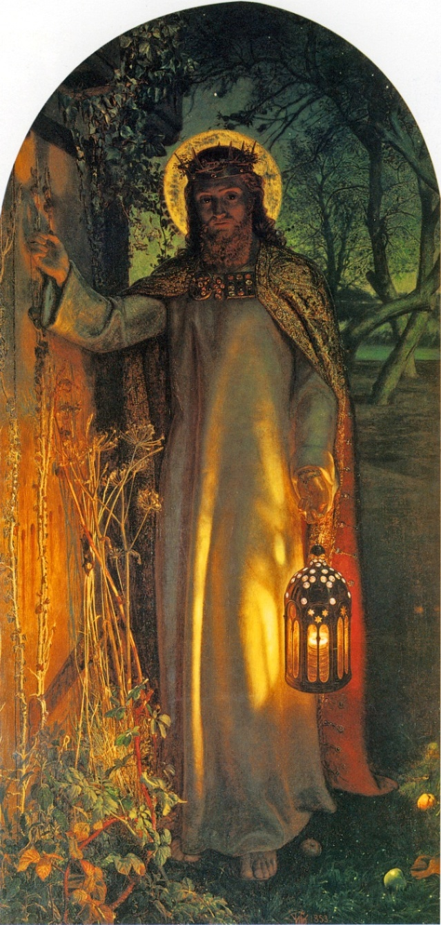
Wondering questions to engage with:
- What do you think the room looks like on the other side of that door?
- When do you think the door will be opened?
- How do you think Jesus feels standing there?
- What will Jesus want to do if/when he is invited inside?
- How will that feel to the person inside?
- How does the painting make you feel?
- What makes you feel hopeful in this painting?
- What would you like to ask the artist?
- What does it suggest to you about his beliefs?

Week 2
Task - Use the words of the hymn ‘Christ Be Our Light’ and say how the lyrics in the hymn are lived out through actions by Christians so they can be like a ‘light in the darkness’.

Christ, Be Our Light by Bernadette Farrell

Longing for light, we wait in darkness
Longing for truth, we turn to You.
Make us Your own, Your holy people
Light for the world to see.
Christ, be our light!
Shine in our hearts.
Shine through the darkness.
Christ, be our light!
Shine in Your church gathered today.

Longing for peace, our world is troubled
Longing for hope, many despair.
Your word alone has pow'r to save us.
Make us your living voice.

Longing for food, many are hungry
Longing for water, many still thirst.
Make us Your bread, broken for others
Shared until all are fed.

Lyric | Action | Shapes Life
Make us your bread, broken for others,  shared until all are fed. | Collecting for local needs e.g. foodbank | Organising fundraising activities involving school council

Week 3

Week 3
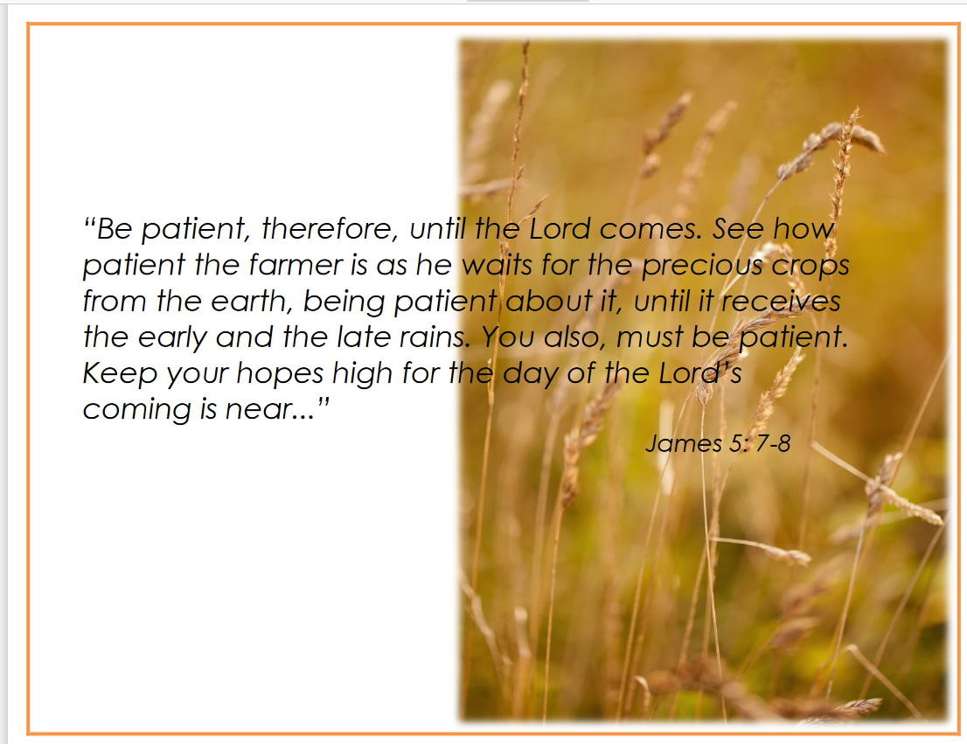

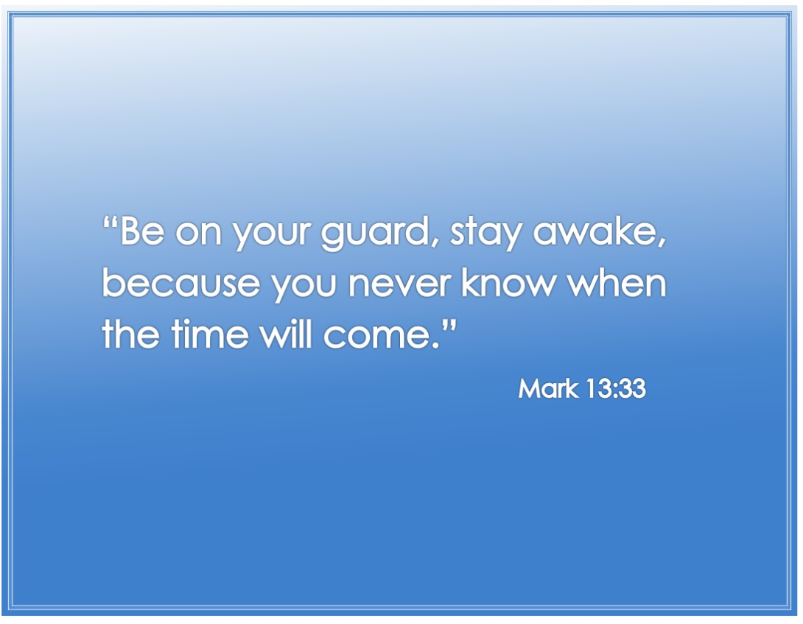

Week 4

Act of Worship

“HOPE”
Year 5
‘Advent is the Church’s season of waiting in joyful hope for the coming
of Jesus, the promised one, at Christmas and at the end of time’.
Put some or all on the sacred space: Advent wreath (or a picture of one) or candle
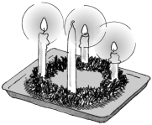
Wrapped presents

Gathering

Together

Bible opened at Isaiah 25:8-9

Let’s begin our prayer In the name of the Father…

Light the appropriate number of candles on the Advent Wreath (or light a single candle and look at a picture of an Advent wreath)

The progressive lighting of the candles on the Advent wreath symbolizes the expectation and hope surrounding our Lord’s first coming into the world and the anticipation of His second coming in glory at the end of time. We have to wait patiently until Christmas Day to light the last candle, the white candle which represents Christ, the Light of the world
Life is full of waiting, we wait at bus stops, railway stations, in queues at the supermarket, and we line up and wait to go into school, into lunch and into the hall for assembly. Sometimes waiting is quite ordinary, sometimes it is frightening or sad: waiting to be found out or told off or waiting to say good bye to someone we love.
Sometimes waiting is exciting, full of fun: waiting for a birthday, for good news, for the arrival of someone we like, for a holiday and for a treat. Every day there are times of waiting. Everyone needs to learn how to wait well. Usually there is no option but to wait, but the important question is how we use the time whilst we are waiting. Good waiting involves hope, and looking forward to what is to come. For Christians the prayer and support of the community help us to wait in hope.
Isaiah was a very important prophet who was born about 765 years before Jesus. He was a skilful poet. He loved God and thought of God as strong and mighty. He trusted in God completely. He tells of the coming of the Messiah. The people in those times were living in kingdoms which were often at war with one another. They yearned for a time of peace and happiness. Isaiah told of the Messiah God would send who would bring peace and justice on earth.

The Word
of God

The people of God had been waiting for a long time for the Promised One of God, the Messiah - the one who would bring blessings. Isaiah wanted to give them hope. People were not quite sure what the Messiah would be like. Isaiah gave them some hints:
A Reading from the Prophet Isaiah
‘… He will wipe away the tears from everyone’s eyes and take away the disgrace his people have suffered throughout the world. The Lord himself has spoken.
When it happens, everyone will say; He is our God! We have put our trust in him, and he has rescued us. He is the Lord! We have put our trust in him, and now we are happy and joyful because he has saved us.’

The Word of the Lord
Thanks be to God.
Isaiah tells us in that reading to be happy and joyful. The rose candle on the Advent wreath is lit on the third Sunday. It is called Gaudete Sunday which means, ‘Joyful Sunday’. This a time of rejoicing, because this is the midpoint of Advent, when the preparation is now half over and Christmas is drawing near.

Response to the Word

So let us be joyful in our response to the reading! The response to our litany is:

We rejoice in the Lord.
We rejoice in the Lord.

Lord, You are very near
We rejoice in the Lord.
You bring us comfort
We rejoice in the Lord.
You can always be trusted
We rejoice in the Lord.
Your birthday is drawing near
We rejoice in the Lord.
Your coming fills us with joy so we can wait in hope
We rejoice in the Lord.

Take a few moments in silence to reflect on how you can use the remaining waiting time of Advent purposefully to show love and service and so be a light to others…….( quiet pause)

Going

Forth

Let us end our prayer as we began – In the name of the Father…

